# Main page

### United States

1. POST /mobilex-us-accounts-eapi-cert-proxy/v3/accounts
2. POST /mobilex-us-customer-eapi-cert-proxy/v1/me

### Global money

1. GET /group-tfx-microservices-fxaas-wallet-america-papi-sct-proxy/v1/wallet/user
2. GET /mobilex-us-globalview-eapi-cert-proxy/v1/accounts

-> GVGT-PAPI /globalAccounts/gv

-> gvgt-sapi /linkedIdentities

-> /wallet-core-us-hbus/api/e2e/v1/wallet-customers

-> /wallet-core-us-hbus/api/e2e/v1/global-wallets/WAxxxx

-> transform to get all wallet balance

-> GMA-PAPI GET /wallet/user

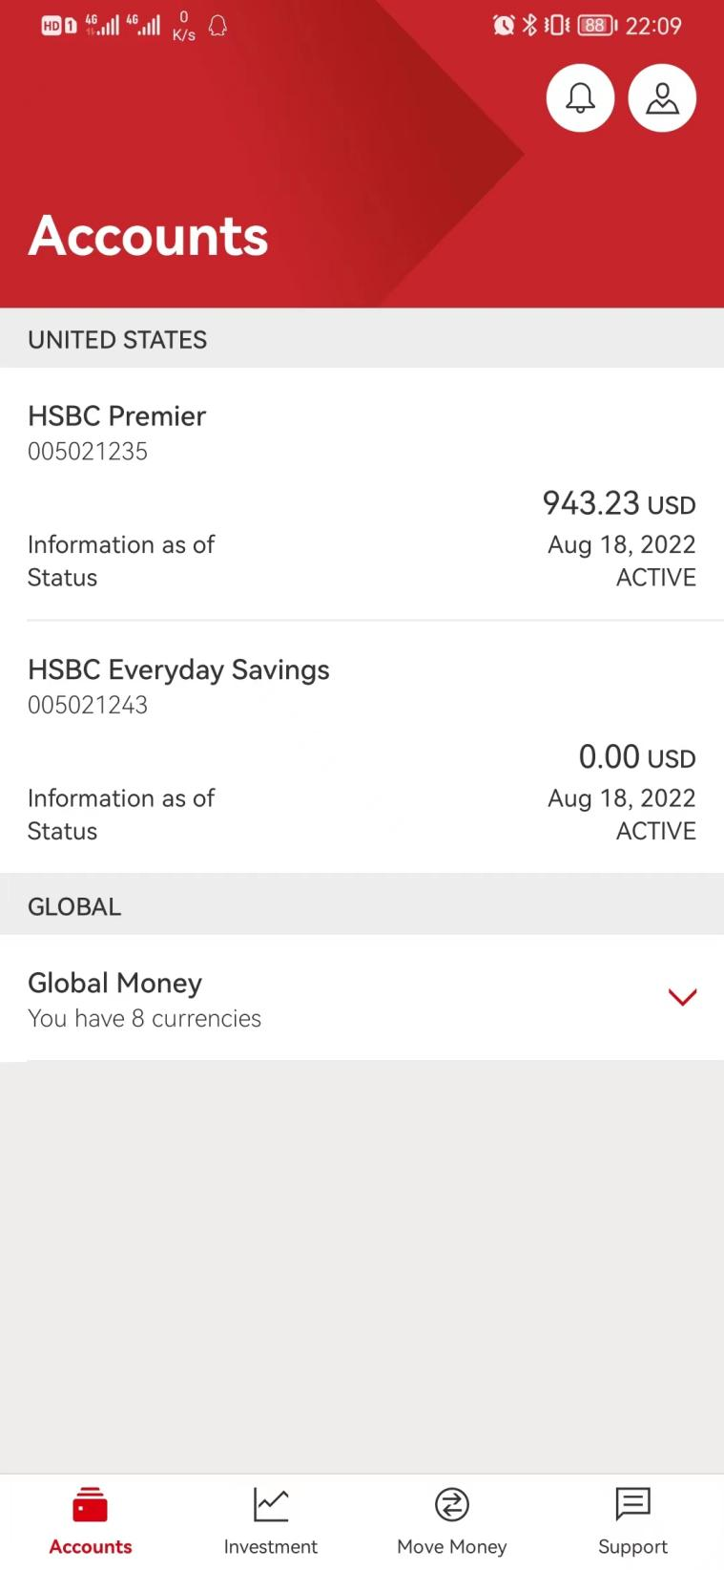

# Move Money

1. GET /group-tfx-eapi-gm-cag-sct-proxy/v1/gmt/user/payment/eligibility

return {“isEligible”:true} -> determine if show two “international”

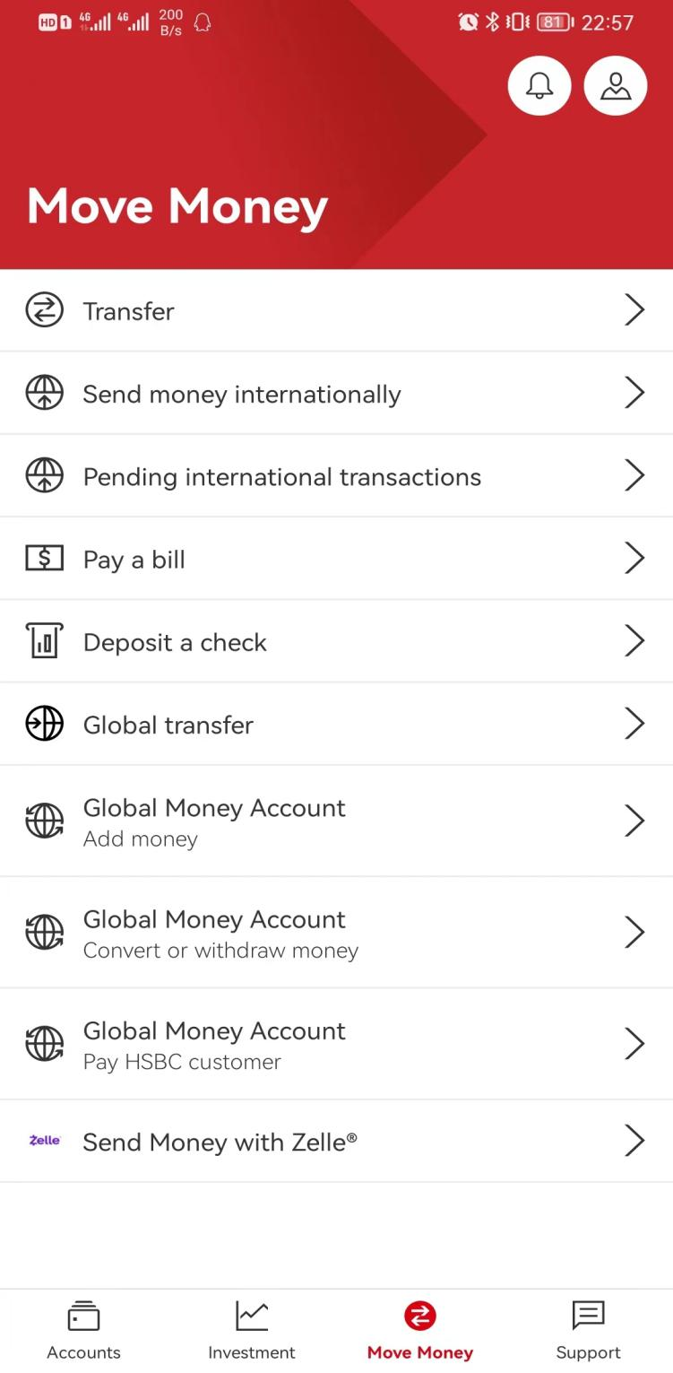

# Transfer(No call)

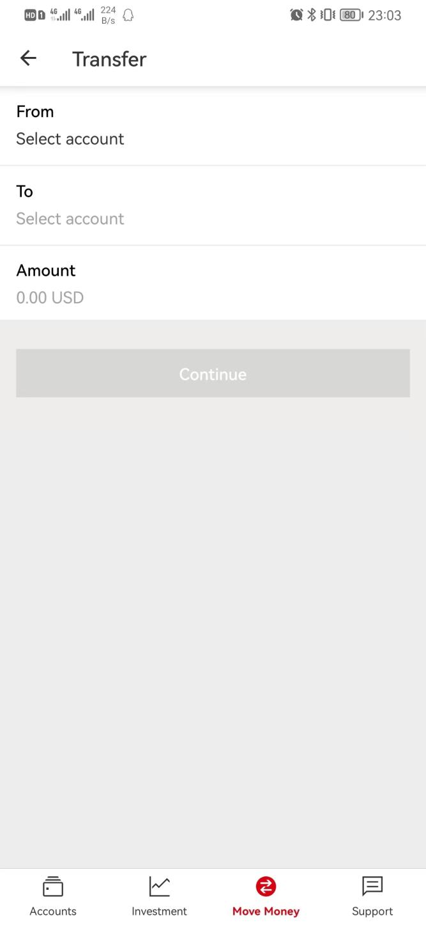

## Select From (hub account)

1. GET /mobilex-us-accounts-eapi-cert-proxy/v3/accounts/move-money

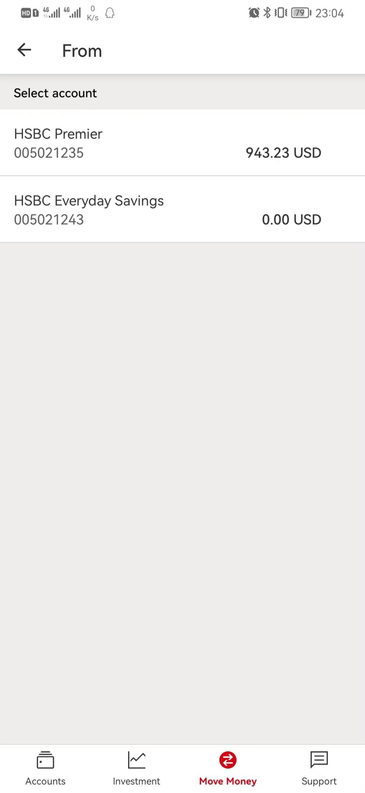

## Select to (hub account)

1. GET /mobilex-us-payments-eapi-cert-proxy/v2/payees/individual?payeeType=other_bank

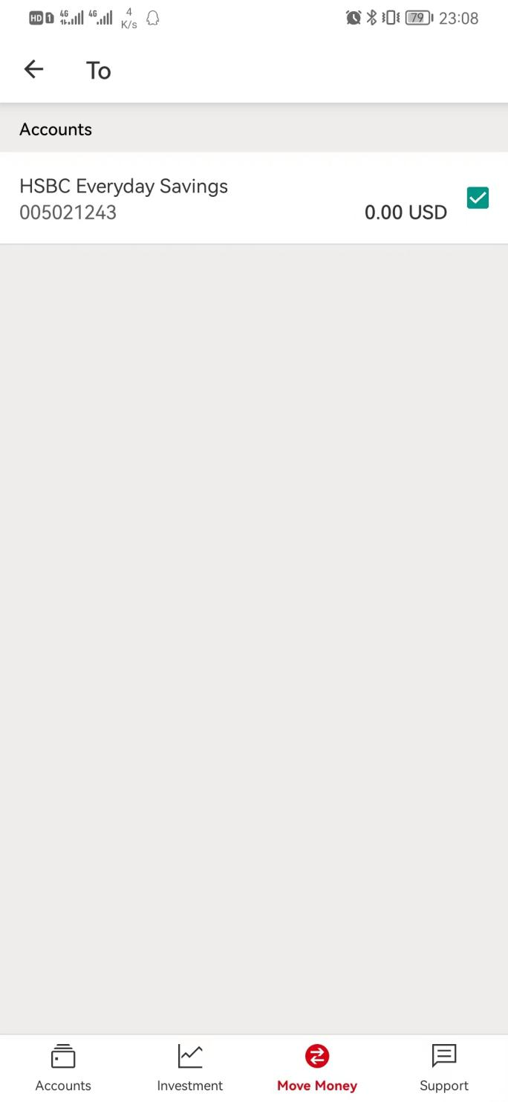

## Input amount (No call)

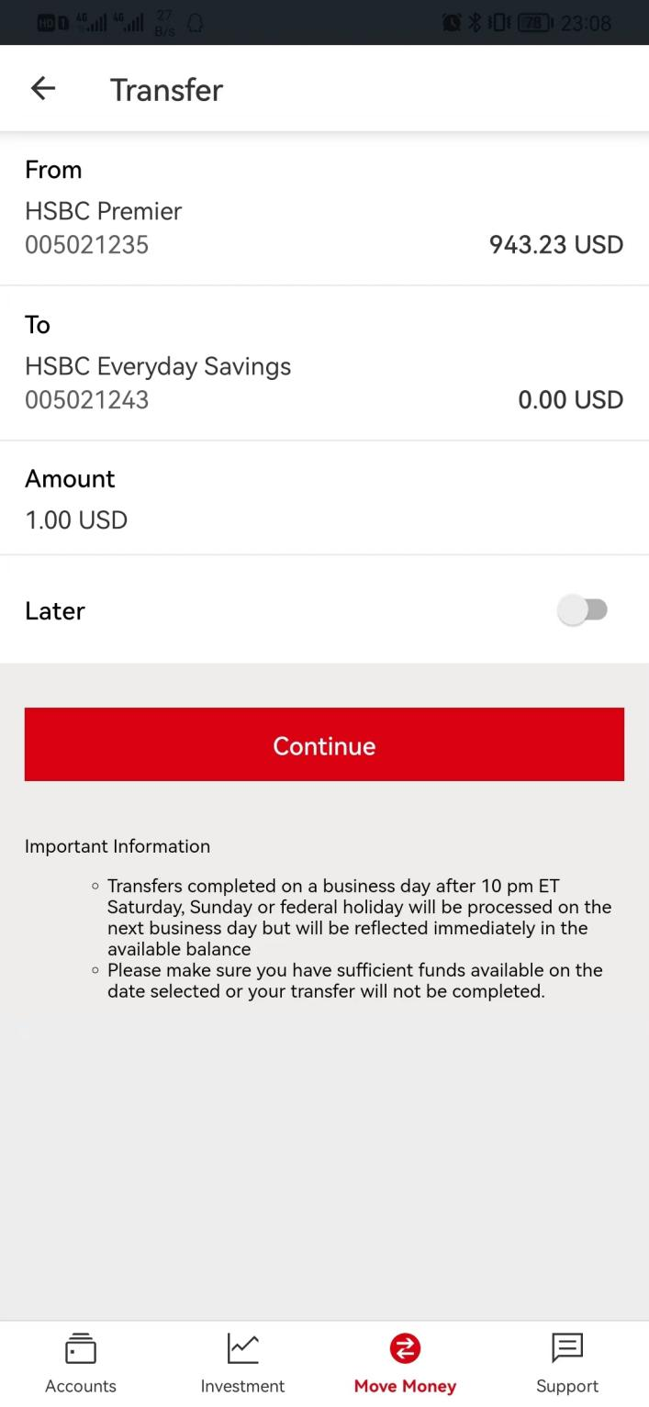

## Continue

1. POST /mobilex-us-transfers-eapi-cert-proxy/v1/verify-domestic-transfer

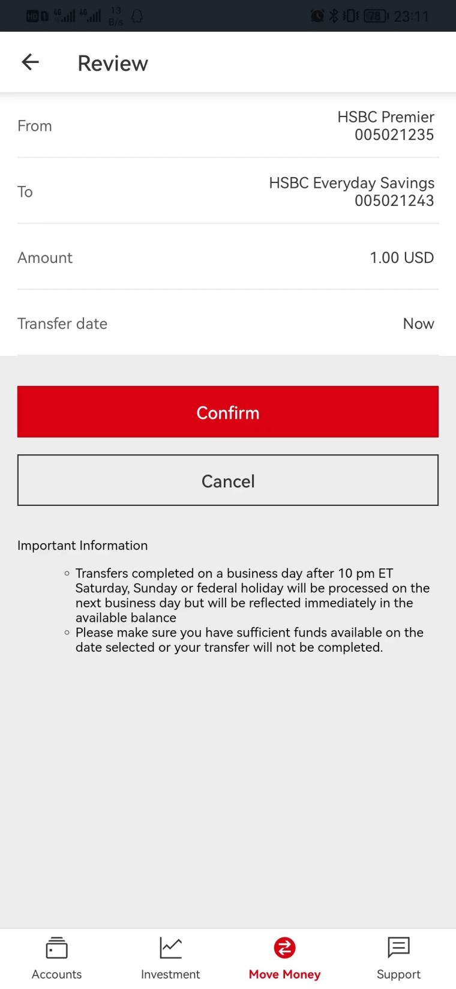

## Confirm

1. POST /mobilex-us-transfers-eapi-cert-proxy/v1/confirm-domestic-transfer

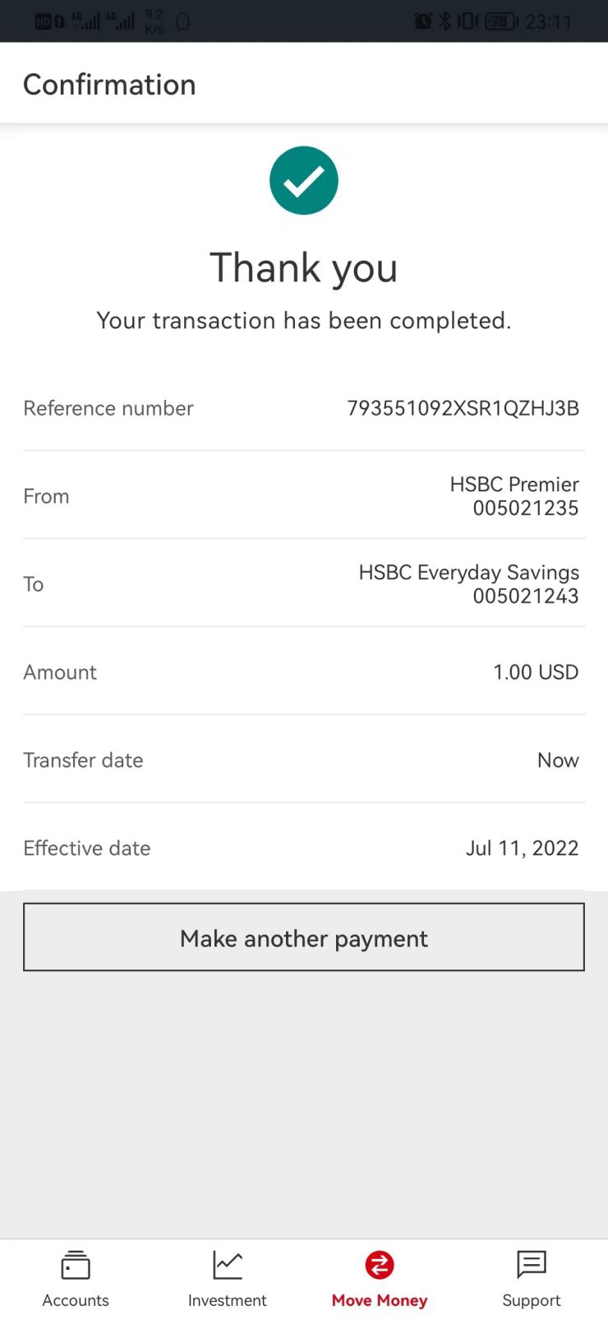

# Send money internationally(GMT)

1. GET /group-tfx-eapi-gm-cag-sct-proxy/v1/gmt/reference-data/payment/main-entity-setting

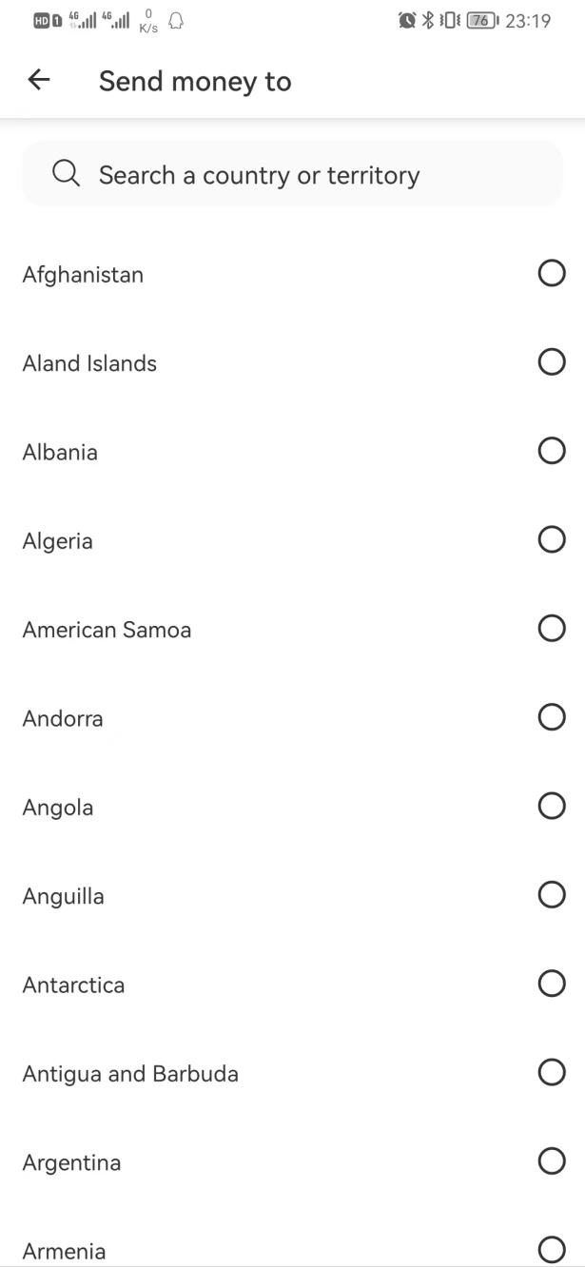

## Select transfer method

Determine GTFF or GD(gdlv/wire) to call /payment-option in coming flow.

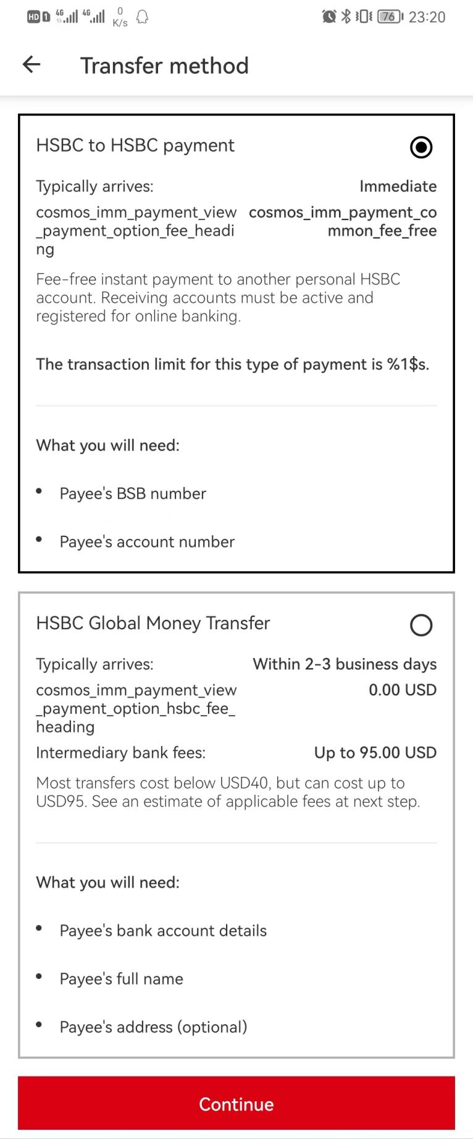

## Continue

* GET /group-tfx-eapi-gm-cag-sct-proxy/v1/gmt/globalAccounts/gt?applicationName=USHUB200&includeLocal=true&addWalletAccount=true

-> return hub and wallet account

* GET /group-tfx-eapi-gm-cag-sct-proxy/v1/gmt/fx-rates?currencyPair=USD-NZD&marginType=CUS_MARGIN&productType=IPT&serviceVersion=V2&applicationName=USHUB200&serviceType=USGPUSPIB&primaryAmount=1000&debitEntity=INTW&debitCountryCode2D=US&creditCountryCode2D=NZ&realTimeInd=true
* POST /group-tfx-eapi-gm-cag-sct-proxy/v1/gmt/payment-option?applicationName=USHUB200

-> to check if can use gtff/gdlv-wire with 0 amount

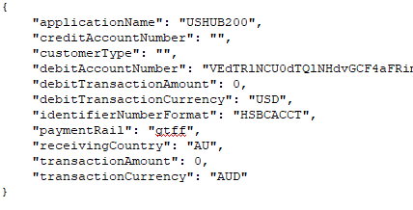

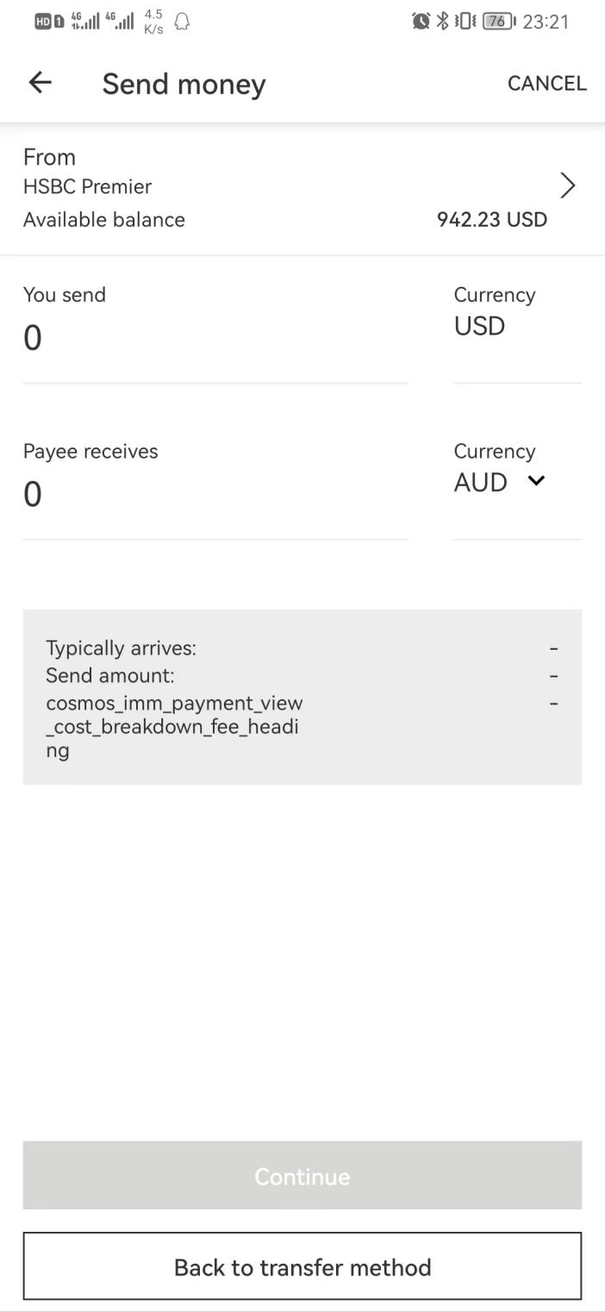

## Select From (hub and wallet)

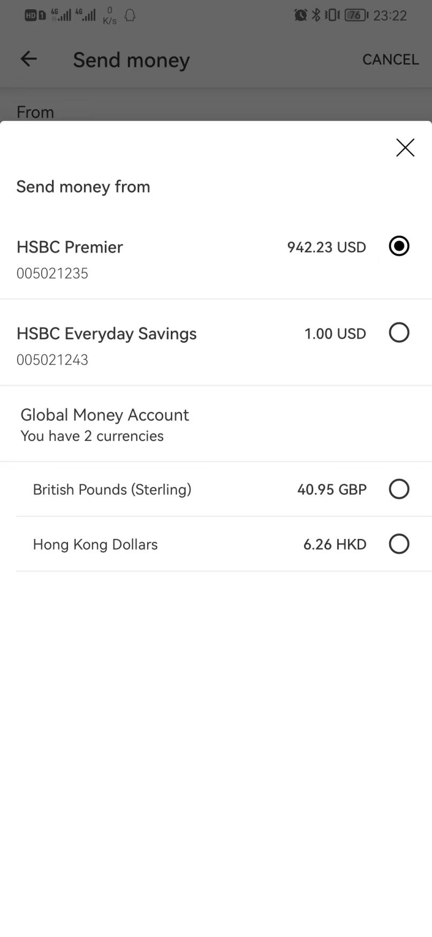

## Input amount

* GET /group-tfx-eapi-gm-cag-sct-proxy/v1/gmt/fx-rates?

currencyPair=USD-AUD&marginType=CUS_MARGIN&productType=IPT&serviceVersion=V2&applicationName=USHUB200&serviceType=USGPUSPIB&primaryAmount=1&debitEntity=INTW&debitCountryCode2D=US&creditCountry2D=AU&realTimeInd=true&paymentRail=gtff

* POST /group-tfx-eapi-gm-cag-sct-proxy/v1/gmt/payment-option?applicationName=USHUB200

--> to check if can use GTFF with amount

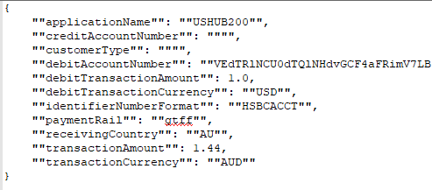

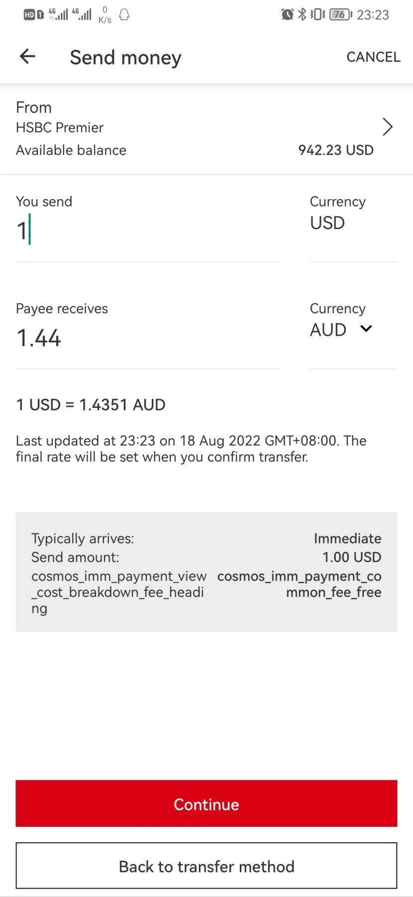

## Continue

* GET /group-tfx-eapi-gm-cag-sct-proxy/v1/gmt/financial-address

-> F/E filter right payee by country and payment method

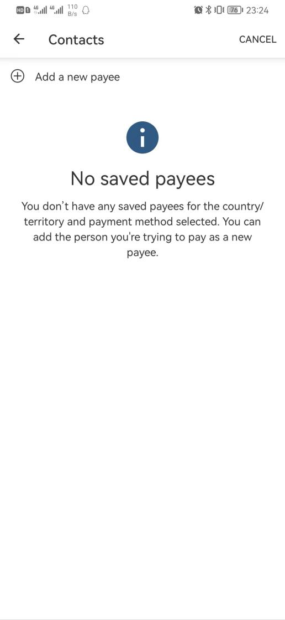

If has right payee:

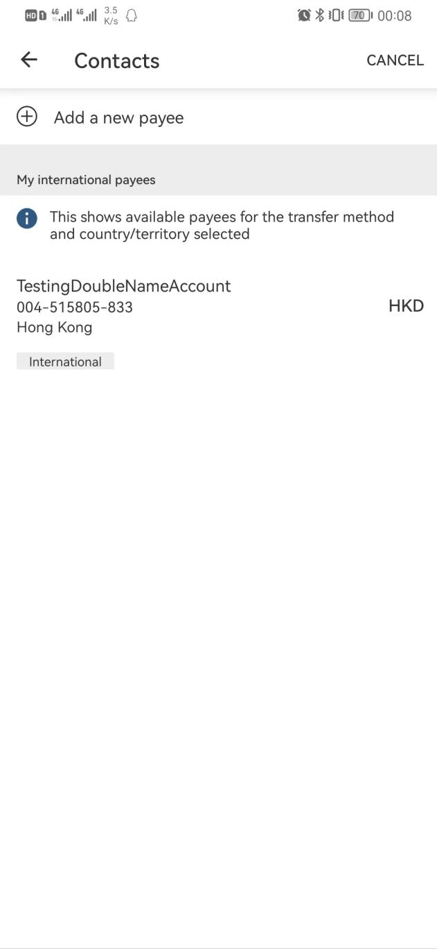

## Select a payee (FCL)

* GET /group-tfx-eapi-gm-cag-sct-proxy/v1/gmt/user
* GET /group-tfx-eapi-gm-cag-sct-proxy/v1/gmt/fx-rates?

currencyPair=USD-HKD&marginType=CUS_MARGIN&productType=IPT&serviceVersion=V2&applicationName=USHUB200&serviceType=USGPUSPIB&primaryAmount=1&debitEntity=INTW&debitCountryCode2D=US&creditCountry2D=AU&realTimeInd=true

* POST /group-tfx-eapi-gm-cag-sct-proxy/v1/gmt/payment-option

--> check with credit account

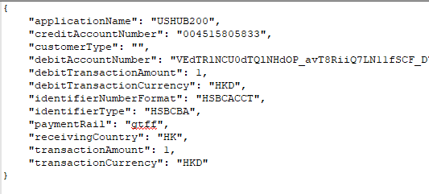

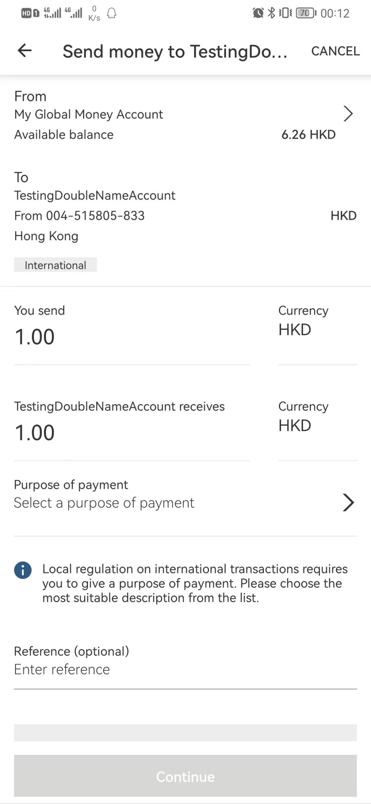

## Purpose of transfer

* GET /group-tfx-eapi-gm-cag-sct-proxy/v1/gmt/reference-data/v1/global-pops?sendingMarket=US&receivingMarket=HK&beneficiaryType=&transferType=M2NM

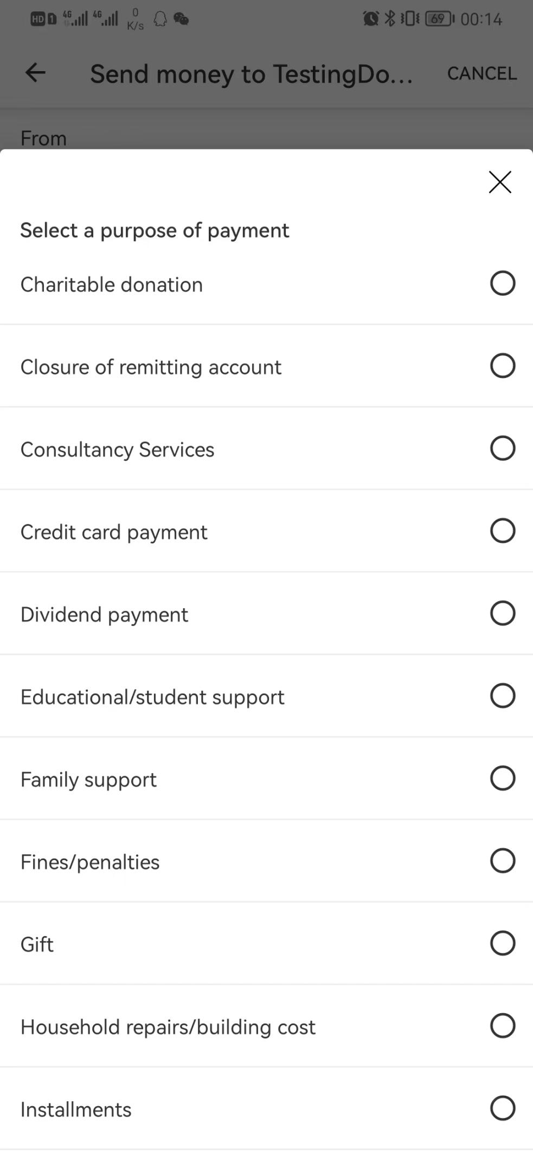

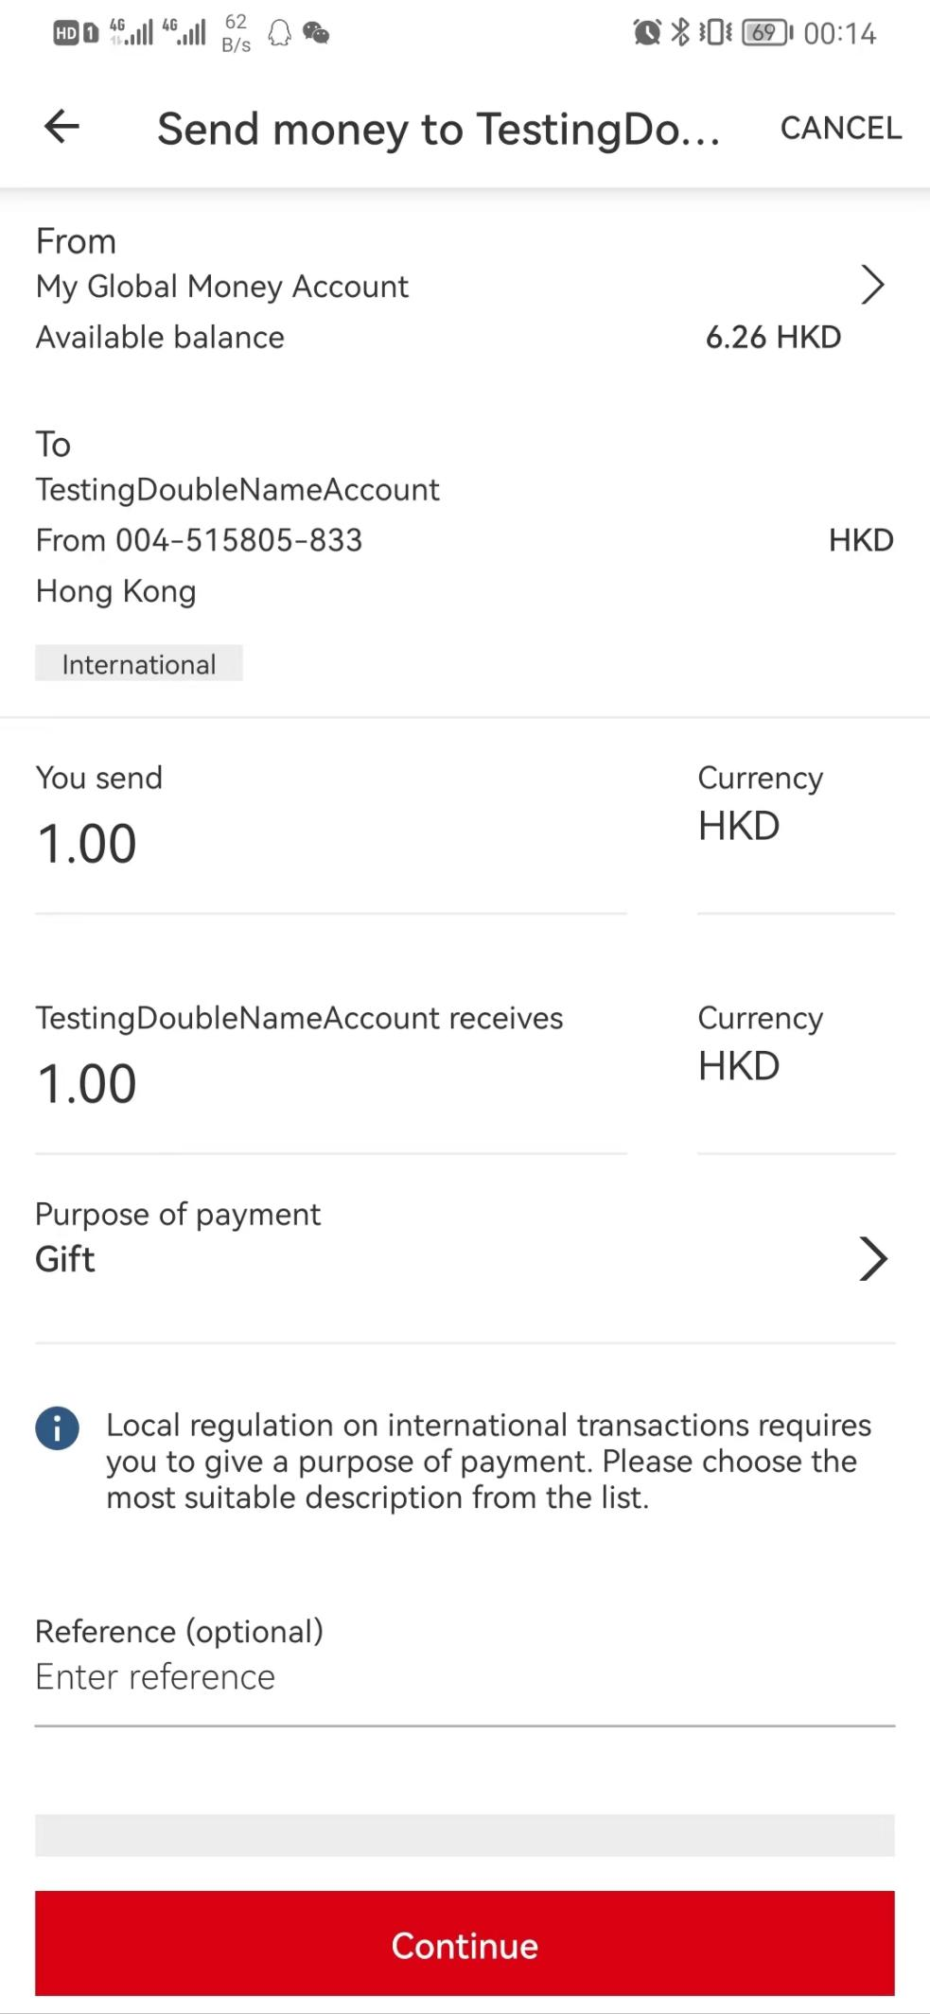

## Continue

If select debit is GMA

* POST /group-tfx-eapi-gm-cag-sct-proxy/v1/gmt/payment/wallet

If select debit is HSBC

* POST /group-tfx-eapi-gm-cag-sct-proxy/v1/gmt/payment

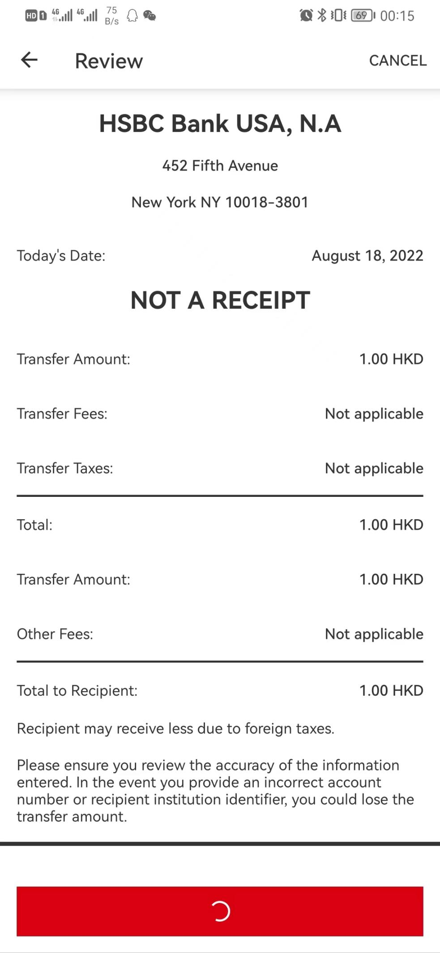

## Confirm

* POST /group-tfx-eapi-gm-cag-sct-proxy/v1/gmt/payment/wallet/GDWxxxx or
* POST /group-tfx-eapi-gm-cag-sct-proxy/v1/gmt/payment/GDWxxxx

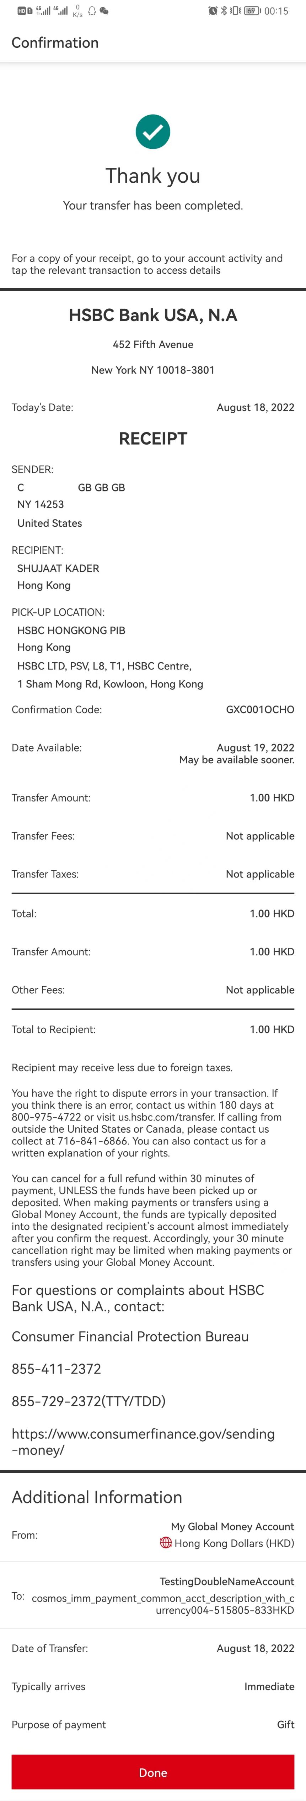

## Add Payee by BIC

* GET /group-tfx-eapi-gm-cag-sct-proxy/v1/gmt/bank-data?bankCountryCode=NZ&isResultReturnPerCode=N&bankCode=NZTRNZ2WXXX&action=VALIDATE

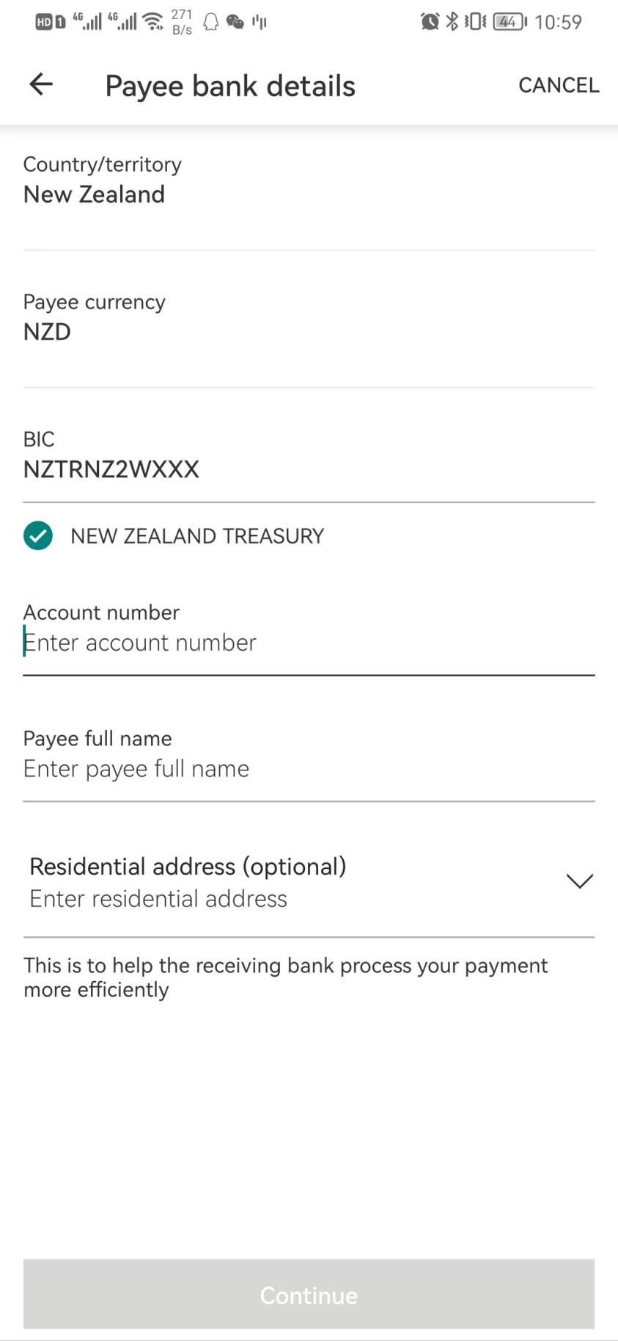

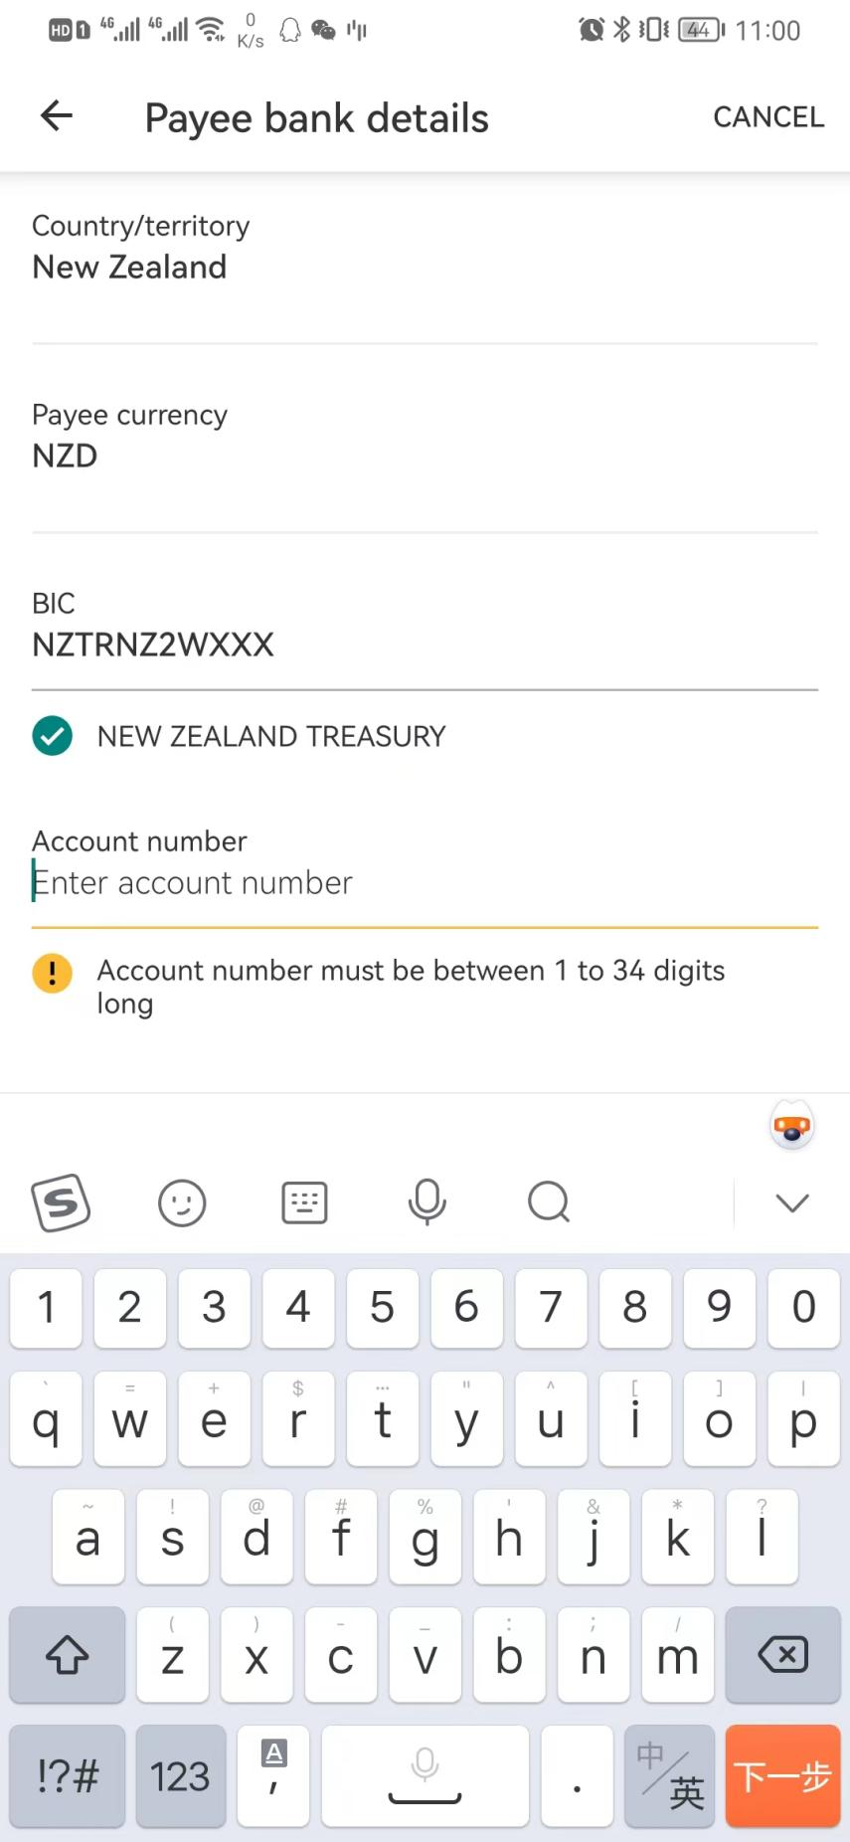

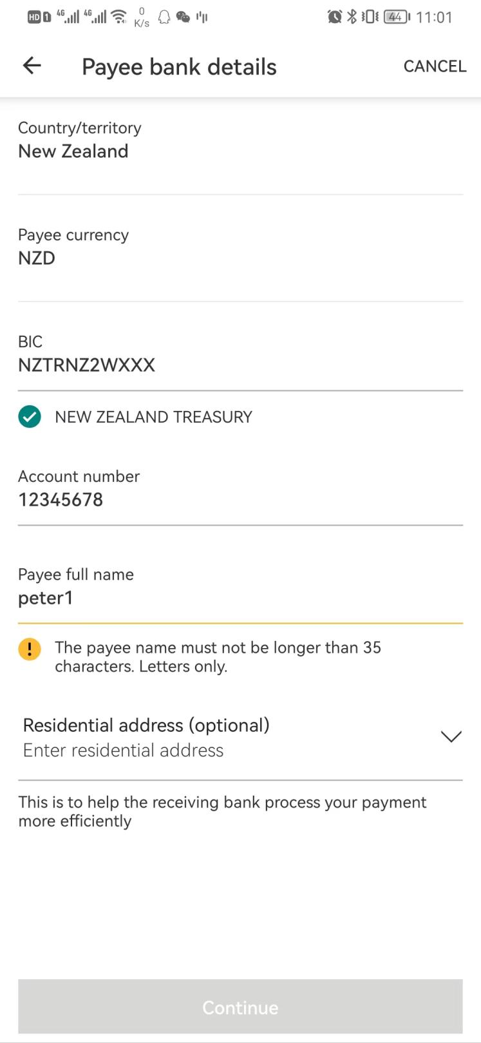

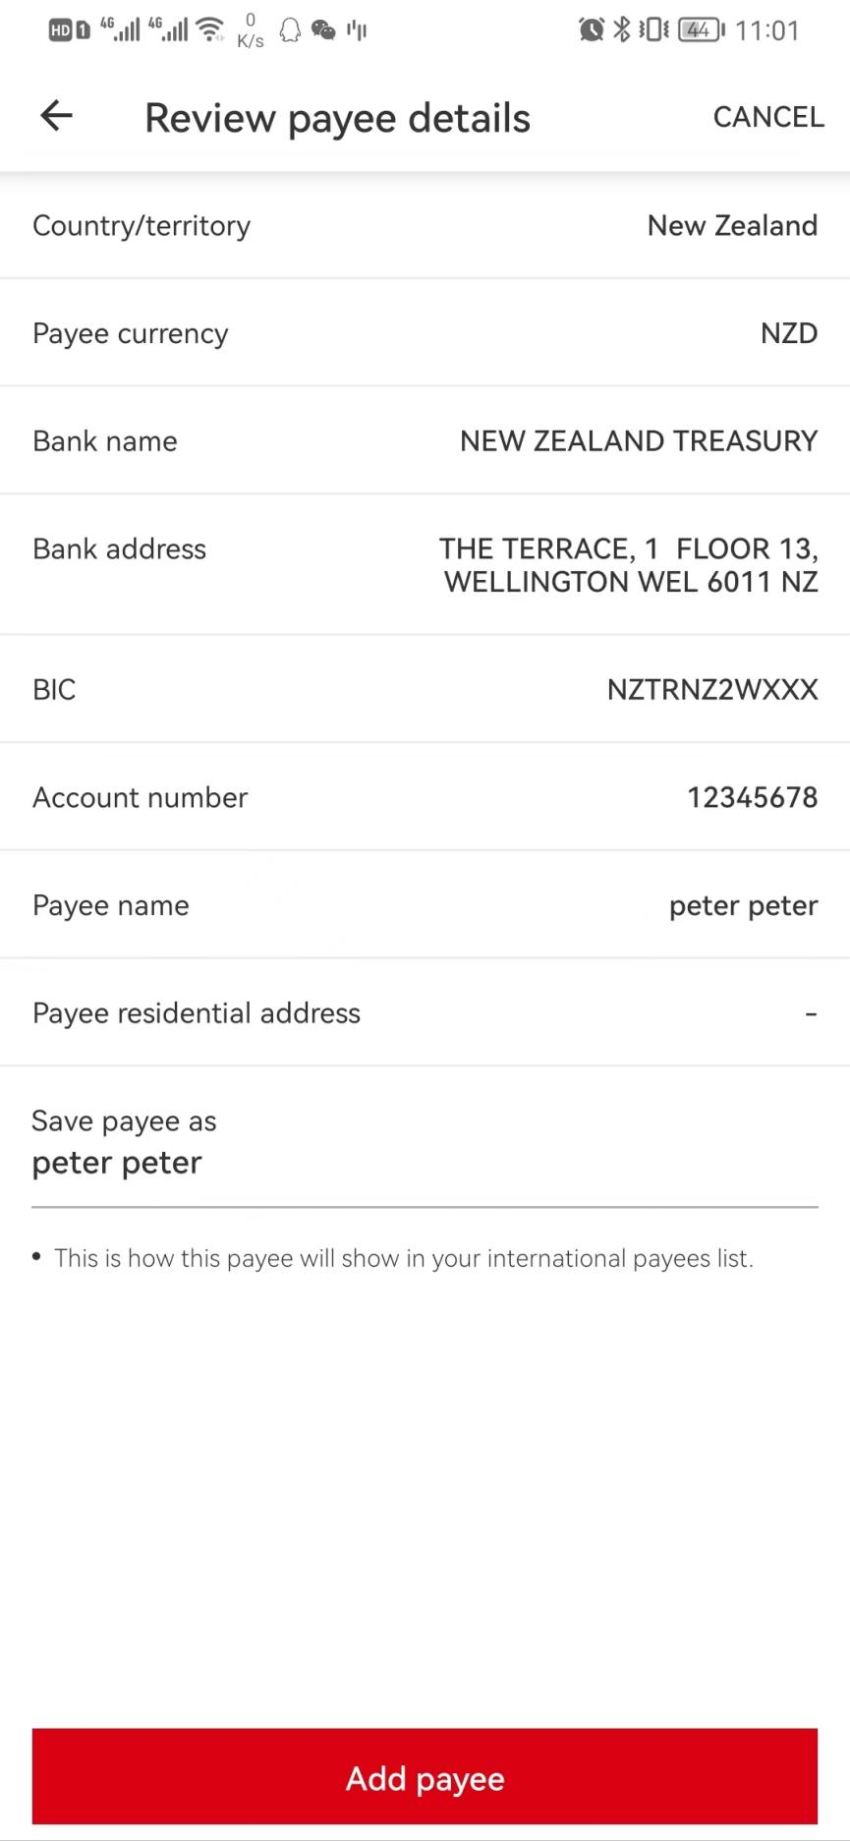

### Continue(no call)

### Add payee

Need to swich device

# Pending International Transactions

* GET /group-tfx-eapi-gm-cag-sct-proxy/v1/gmt/transaction/payment?applicationName=USHUB200&paymentRail=NOT_GTFF&transactionStatus=COOLING&transactionType=HSBC_ACCOUNT_TO_PAYEE&order=DESC&orderBy=lastModifiedDate&limit=20&offset=1

# Pay a bill

## Select debit

* GET /mobilex-us-accounts-eapi-cert-proxy/v3/accounts/move-money

## Select credit

* GET /dcc-us-hbus-mvmny-payee-management-papi-cert-proxy/v2/payees?payeeCategory=BILLER

# Deposit a check

* POST /mobilex-us-cheque-deposit-eapi-cert-proxy/v1/accounts-limits

# Global transfer

## Select from

* POST /mobilex-us-globaltransfers-eapi-cert-proxy/v1/accounts/global-transfers

## To account

* POST /mobilex-us-globaltransfers-eapi-cert-proxy/v1/accounts/global-transfers

# Global Money Account (TOPUP)

## Select from (hub account)

* GET /group-tfx-microservices-fxaas-wallet-america-papi-sct-proxy/v1/wallet/entity/setting?applicationName=USHUB200

--> return

{

"supportedCurrencies": ["EUR", "GBP", "CAD", "AUD", "NZD", "USD", "HKD", "SGD"],

"topCurrencies": ["GBP", "USD", "HKD"],

"bicCode": "MRMDUS33",

"fundingAccountTypes": ["CN7", "CA5", "CA8", "CUV", "CA9", "SVO", "SSI", "SV6", "SSV", "SSL", "PSA", "PPS", "SV7", "SSF"]

}

* GET /group-tfx-microservices-fxaas-wallet-america-papi-sct-proxy/v1/globalAccounts/gt?applicationName=USHUB200&includeLocal=true&addWalletAccount=true

--> only show hub account

## Select to (wallet)

Only show wallet account with balance

## Input amount

* GET /group-tfx-microservices-fxaas-wallet-america-papi-sct-proxy/v1/fx-rate/wallet?currencyPair=USD-HKD&marginType=CUS_MARGIN&productType=HGM&serviceVersion=V2&applicationName=USHUB200&serviceType=USGPUSPIB&primaryAmount=10&debitEntity=INTW&creditEntity=INTW&debitCountryCode2D=US&creditCountryCode2D=US&debitAccountType=CA9&realTimeInd=true

## Continue

* POST /group-tfx-microservices-fxaas-wallet-america-papi-sct-proxy/v1/transfer/wallet?applicationName=USHUB200

## Confirm

* POST /group-tfx-microservices-fxaas-wallet-america-papi-sct-proxy/v1/transfer/wallet/GDWM000002929253?applicationName=USHUB200

# Global Money Account (withdraw)

## Select from(wallet)

* GET /group-tfx-microservices-fxaas-wallet-america-papi-sct-proxy/v1/wallet/entity/setting?applicationName=USHUB200

--> return

{

"supportedCurrencies": ["EUR", "GBP", "CAD", "AUD", "NZD", "USD", "HKD", "SGD"],

"topCurrencies": ["GBP", "USD", "HKD"],

"bicCode": "MRMDUS33",

"fundingAccountTypes": ["CN7", "CA5", "CA8", "CUV", "CA9", "SVO", "SSI", "SV6", "SSV", "SSL", "PSA", "PPS", "SV7", "SSF"]

}

* GET /group-tfx-microservices-fxaas-wallet-america-papi-sct-proxy/v1/globalAccounts/gt?applicationName=USHUB200&includeLocal=true&addWalletAccount=true

--> only show wallet account with currency

## Select to(wallet and hub)

Get all account from last step /v1/globalAccounts/gt

### Input amount

* GET /group-tfx-microservices-fxaas-wallet-america-papi-sct-proxy/v1/fx-rate/wallet?currencyPair=HKD-USD&marginType=CUS_MARGIN&productType=HGM&serviceVersion=V2&applicationName=USHUB200&serviceType=USGPUSPIB&primaryAmount=10&debitEntity=INTW&creditEntity=INTW&debitCountryCode2D=US&creditCountryCode2D=US&debitAccountType=WAL&realTimeInd=true

### Continue

* POST /group-tfx-microservices-fxaas-wallet-america-papi-sct-proxy/v1/transfer/wallet?applicationName=USHUB200

### Confirm

* POST /group-tfx-microservices-fxaas-wallet-america-papi-sct-proxy/v1/transfer/wallet/GDWM000002929254?applicationName=USHUB200

## Select to (payees)

* GET /group-tfx-microservices-fxaas-wallet-america-papi-sct-proxy/v1/payees?applicationName=USHUB200&productType=gtff

### Select a payee

* GET /group-tfx-microservices-fxaas-wallet-america-papi-sct-proxy/v1/reference-data/purpose-of-payment?targetCountryCode=UK&applicationName=USHUB200

### Input amount

* GET /group-tfx-microservices-fxaas-wallet-america-papi-sct-proxy/v1/fx-rate/wallet?currencyPair=HKD-GBP&marginType=CUS_MARGIN&productType=HGM&serviceVersion=V2&applicationName=USHUB200&serviceType=USGPUSPIB&primaryAmount=10&debitEntity=INTW&creditEntity=E422&debitCountryCode2D=US&creditCountryCode2D=UK&debitAccountType=WAL&realTimeInd=true

### Continue

* POST /group-tfx-microservices-fxaas-wallet-america-papi-sct-proxy/v1/payment/wallet?applicationName=USHUB200

### Confirm

* POST /group-tfx-microservices-fxaas-wallet-america-papi-sct-proxy/v1/payment/wallet/GDWM000002929256

# Global Money Account (pay HSBC customer)

## Select from(wallet)

* GET /group-tfx-microservices-fxaas-wallet-america-papi-sct-proxy/v1/wallet/entity/setting?applicationName=USHUB200
* GET /group-tfx-microservices-fxaas-wallet-america-papi-sct-proxy/v1/globalAccounts/gt?applicationName=USHUB200&includeLocal=true&addWalletAccount=true

-> only show wallet account

## Select to(wallet and hub)

Get all account from last step /v1/globalAccounts/gt

### Input amount

* GET /group-tfx-microservices-fxaas-wallet-america-papi-sct-proxy/v1/fx-rate/wallet?currencyPair=HKD-USD&marginType=CUS_MARGIN&productType=HGM&serviceVersion=V2&applicationName=USHUB200&serviceType=USGPUSPIB&primaryAmount=10&debitEntity=INTW&creditEntity=INTW&debitCountryCode2D=US&creditCountryCode2D=US&debitAccountType=WAL&realTimeInd=true

### Continue

* POST /group-tfx-microservices-fxaas-wallet-america-papi-sct-proxy/v1/transfer/wallet?applicationName=USHUB200

### Confirm

* POST /group-tfx-microservices-fxaas-wallet-america-papi-sct-proxy/v1/transfer/wallet/GDWM000002929258?applicationName=USHUB200

## Select to (payees)

* GET /group-tfx-microservices-fxaas-wallet-america-papi-sct-proxy/v1/payees?applicationName=USHUB200&productType=gtff

### Input amount

* GET /group-tfx-microservices-fxaas-wallet-america-papi-sct-proxy/v1/reference-data/purpose-of-payment?targetCountryCode=HK&applicationName=USHUB200
* GET /group-tfx-microservices-fxaas-wallet-america-papi-sct-proxy/v1/fx-rate/wallet?currencyPair=USD-HKD&marginType=CUS_MARGIN&productType=HGM&serviceVersion=V2&applicationName=USHUB200&serviceType=USGPUSPIB&primaryAmount=10&debitEntity=INTW&creditEntity=IUAT&debitCountryCode2D=US&creditCountryCode2D=HK&debitAccountType=WAL&realTimeInd=true

### Continue

* POST /group-tfx-microservices-fxaas-wallet-america-papi-sct-proxy/v1/payment/wallet?applicationName=USHUB200

### Confirm

* POST /group-tfx-microservices-fxaas-wallet-america-papi-sct-proxy/v1/payment/wallet/GDWM000002929257?applicationName=USHUB200